**Assignment 5.1**

**Access the “xml” file in excel and save it to a comma delimited “csv” file**

1. Click file and select “Save As”
2. Enter file name and select CSV(comma delimited) under save as type option



**Make all the rows where “attractiveness<6” to background color = red, font = 8, font type = italic**

1. Select the whole attractiveness column and click conditional formatting tab under Home ribbon
2. In conditional formatting select highlight cell rules and select less than option and enter 6

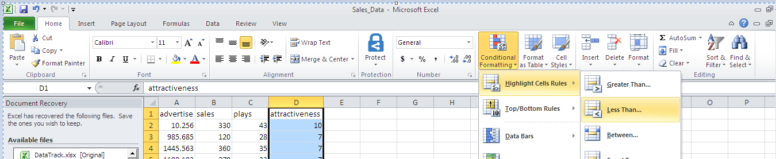

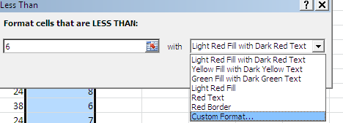

1. Under custom format, select fill option to give background color and font option to update font type. Unable to give font size

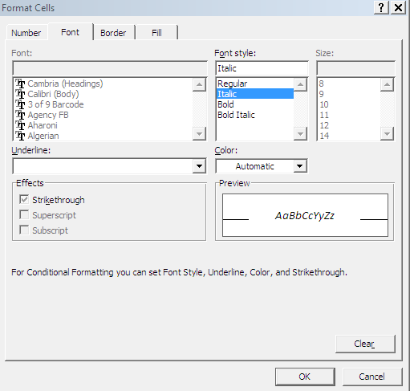

**Hide All the rows where “attractiveness<6” by using grouping. Hide in the sense, we should be able to see there is some rows there, which we can unfold to see. Also try hiding the data without grouping**

1. Select all rows and columns. Under data ribbon, click sort , sort by attractiveness value -> smallest to largest

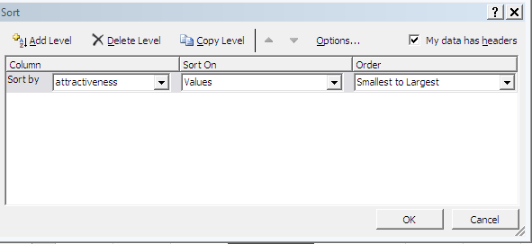

1. Select the rows where “attractiveness<6”

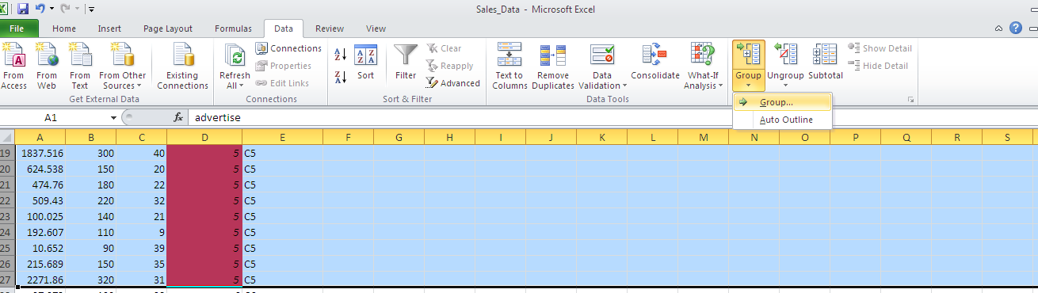

1. Hiding data without grouping can done using filter option .Under data ribbon click filter option.

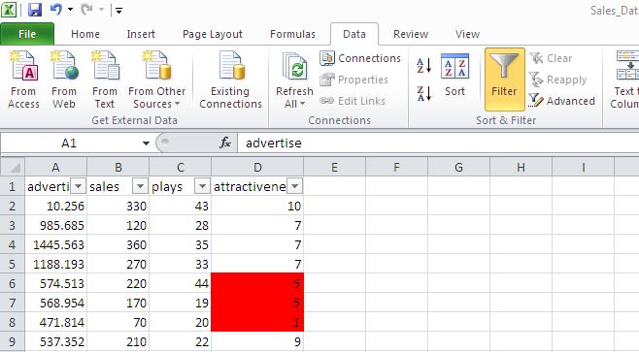

1. Click filter in attractiveness column -> Number filter -> less than option

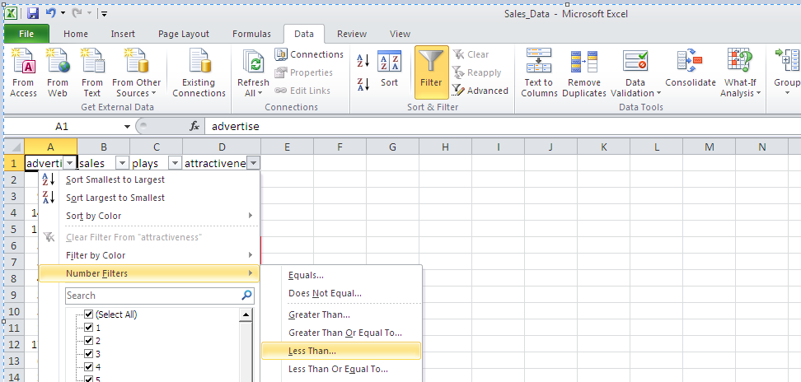

1. Give 6 and click ok.

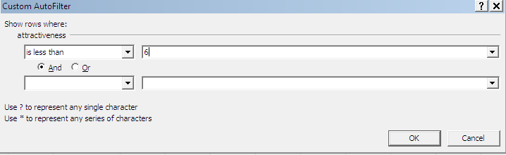

**Use the same data. The column named “attractiveness” is in general format. It is actually a rating from 1 to 10. Can you prepend “C” before the number. i.e. if it is 1, it should be converted to “C1”. Format the column to text type.**

1. In a new column type the formula “=CONCATENATE("C",D2)” and enter.
2. Select the resultant column, under Home ribbon select text and change the column to text type

